**File System Management**

1. List out 5 files in your system which consuming most of the disk space

**USED COMMANDS:-**

ubuntu@ip-172-31-30-52:~$ df -hm | sort -nrk2 | head -n6

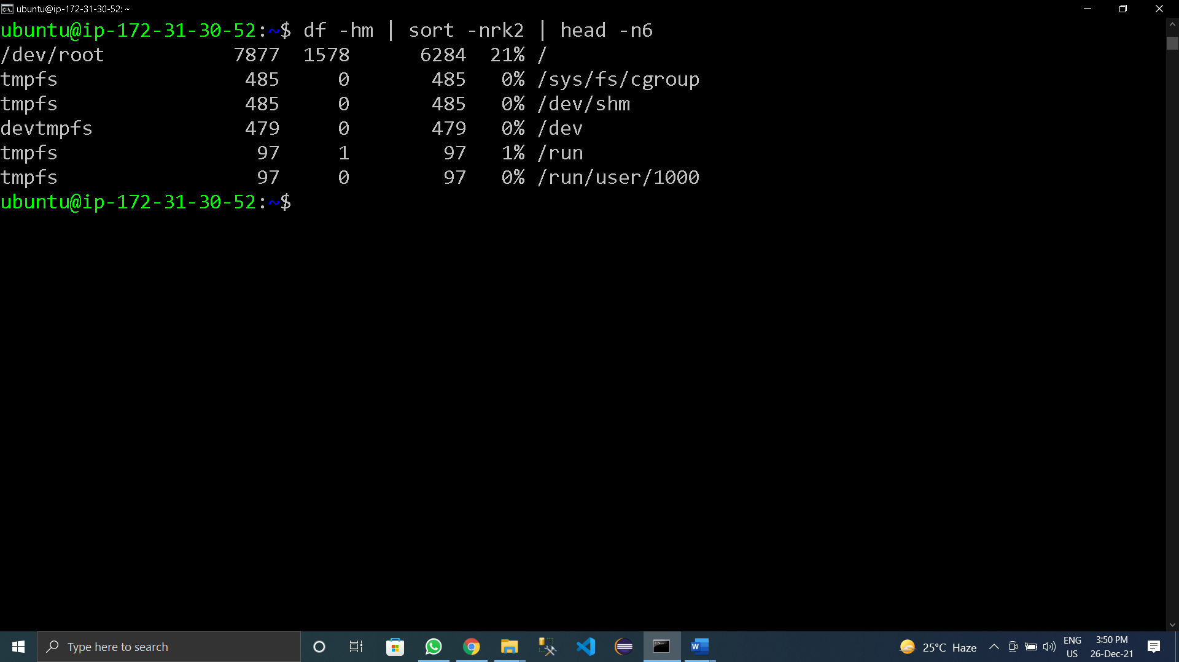

1. Create one common folder in such way that anyone can create files inside that independently and should not be able to delete other users files from that common folder.

**COMMANDS USED:-** ubuntu@ip-172-31-30-52:~$ mkdir LinuxDir

ubuntu@ip-172-31-30-52:~$ ls -l

ubuntu@ip-172-31-30-52:~$ chmod o+t LinuxDir/

ubuntu@ip-172-31-30-52:~$ ls -l

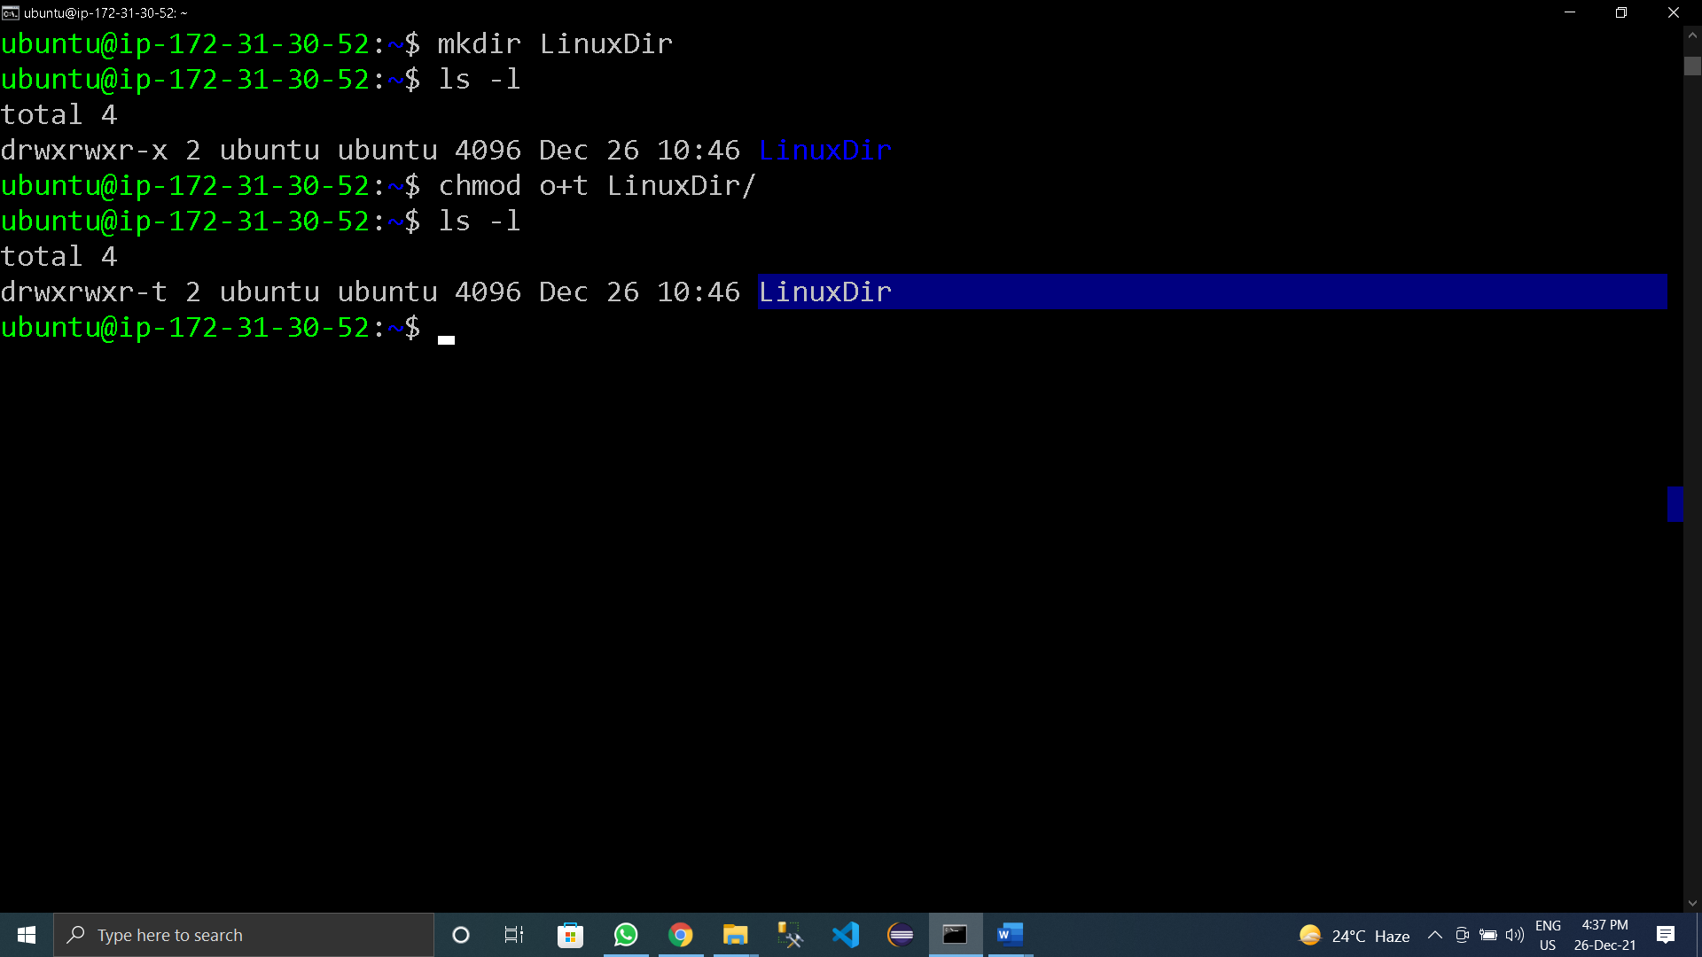

1. Create user name "shubham" and add that user in the group "adm"

**COMMANDS USED:-**

ubuntu@ip-172-31-30-52:~$ cd /home/

ubuntu@ip-172-31-30-52:/home$ cd /

ubuntu@ip-172-31-30-52:/$ sudo mkdir data

ubuntu@ip-172-31-30-52:/$ ls -l | grep data

ubuntu@ip-172-31-30-52:/$ sudo chown root:adm data/

ubuntu@ip-172-31-30-52:/$ ls -l | grep data

ubuntu@ip-172-31-30-52:/$ cd data

ubuntu@ip-172-31-30-52:/data$ sudo touch test.txt

ubuntu@ip-172-31-30-52:/data$ ls -l

ubuntu@ip-172-31-30-52:/data$ sudo chown -R root:adm /data/

ubuntu@ip-172-31-30-52:/data$ ls -l

total 0

-rw-r--r-- 1 root adm 0 Dec 26 14:08 test.txt

ubuntu@ip-172-31-30-52:/data$